Doris Blasting System
Safety, Operations & Maintenance Guide

Safety

Operators Competence

DSGL recommend that all personnel, prior to using our system within the workplace, receive appropriate training on the safe operation and maintenance of the Doris Blasting System.

PPE

The Doris Blasting System can be used for various applications and DSGL recommend that the company utilising the system undertake their own risk assessment before identifying the appropriate PPE to be worn by the operator. DSGL however, recommend a minimum amount of PPE that must be used at all times when operating our system:-

- Respiratory Solution;
- Face & Eye Protection;
- Ear Protectors (plugs);
- Overalls;
- Gloves;
- Safety Boots;

Illustrated below is the approved Doris Respiratory System. This also provides face and eye protection whilst using the Doris System to undertake blast cleaning activities within a ventilated area.

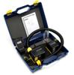 | COMPACT AIR ® Blower Unit with NiMH battery, intelligent charger, airflow indicator, belt and hose with bayonet connection.
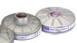 | NORTH FILTERS for use with the Compact Air Blower Unit, Compact Air Plus & Airbelt
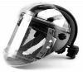 | JUNIOR A-Combi-vl with safety helmet, face seal, Comfa seal® and sweatbands

Maintenance

Maintenance Schedule
DSGL recommend the Doris System should receive a full service by qualified personell anually, to avoid performance deteriation and to ensure all safety features are functioning correctly.

The full system i.e. Gun, Pot and Hoses etc must be visually inspected after assembly, and before use, to ensure safe operation.

For further information on maintenance schedules and servicing contact DSGL on 0845 39 00 777.

Operating

Connection Instructions
The following guide must be adhered to when assembling the Doris System:-
- Always keep the two hoses separate as using the abrasive media hose for air delivery can cause damage to the main valve by abrasive particles passing through. The abrasive media hose can be identified from the air hose as it has been coloured Black with a Red stripe;
- Do not use the abrasive media hose as a air delivery hose or with any other system than the Doris;
- Never store hoses inside a hot compressor, allow the pot to cool down first before storing parts inside;
- Avoid sharp coils when rolling the hoses up as this is the main cause of hose cracks and splits;
- Before taking the system apart, run the system with air only to expel any abrasive media and moisture from the gun;
- Please ensure the system is connected as follows:-

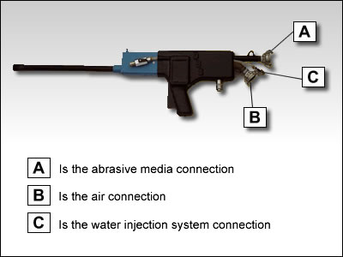
(Fig 1)

System Controls
The controls to the Doris system are solely with the operator which ensures that once the trigger is released, the system shuts down immediately. The controls are as follows:-
(Fig 2)
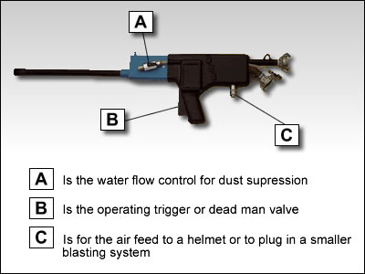

Ejecting of Blockages
If a blockage occurrs while the water injection system has been used (wet blast), the following action must be taken:

- Disconnect the abrasive media hose from the media container (black and red stripe)
- Turn off the water injection control valve
- Place hose to the ground and hold down with foot
- Place the blast barrel against a flat surface
- Operate trigger until blockage has been ejected
- Reconnect abrasive media hose.

If a blockage occurrs while the system has been operated as a dry blast system the following action must be taken:-

- Place blast barrel against a flat surface and operate the trigger until blockage has been ejected.

The majority of blockages are caused due to unrecognized media types and sizes, if there is any doubt in the quality of abrasive media it must not be used with the system. DSGL supply an approved range of recycled media capable of reaching all necessary finishes. Contact the DSGL Office for further guidance.

If whilst using the water injection system, it is left un-operated for a few minutes, it must be run dry for a few seconds to avoid blockages from a wet abrasive build up.

When blast cleaning at height, the media container can be operated from the ground level. However, the water container used for dust suppression will need to be sited at the same level as the operator.

Once blast cleaning has been completed, the system must be run dry with the media delivery hose disconnected to clear the gun of any debris or moisture that may have collected within the gun during use.

Power Washing
The Doris System also has a power washing facility. To operate as a power washer, simply assemble the system in the same manner as a dry blast system but using water in place of blasting media in the media container.

DSGL operater a full in-depth training course covering all aspects of operation of the Doris System. The course covers health & safety and risk assessment for sites and public places, for further details, please contact 0845 39 00 777.

